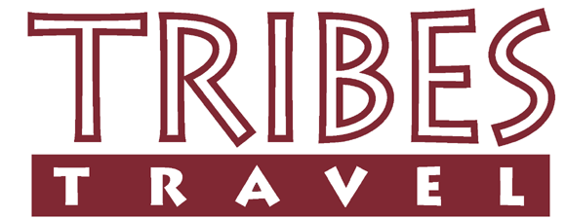

SOCIAL & ENVIRONMENTAL RESPONSIBILITY REPORT

FOR
MARA PORINI CAMP IN KENYA

Tribes has awarded Mara Porini Camp with the following ratings.
The Recognition rating is for environmental responsibility and the Fair Trade Travel rating is for social responsibility.

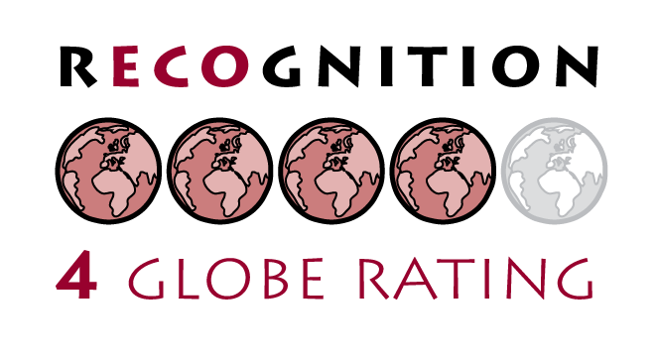

ENVIRONMENTAL RESPONSIBILITY

The Mara Porini Camp manage a community-owned conservancy which actively protects the natural local area.

Water saving at the camp is taken very seriously, and the practises are discussed with the guests upon their arrival. Water is pumped into a main tank each day and from there it is gravity fed to all areas greatly minimising the need for using an energy source. The camp also uses solar power for lighting.

Biodegradable packaging is used for many of the supplies at the camp, and non-toxic detergents and cleaning products are used.

SOCIAL RESPONSIBILITY

Mara Porini is a camp which is very much a partnership with the local Maasai community. The community benefits as a whole thanks to bed night fees and land rental payments, and also the camp brings employment.

About three quarters of the staff at the camp are employed from the local area. The camp has contributed to the local community infrastructure by building a foot bridge to enable the river to be crossed at all times, and 2 boreholes were also installed.

